1️⃣ Sentence Transformers (all-MiniLM-L6-v2)

What it is:
- A pre-trained transformer model designed to convert text into dense vector embeddings (numerical representations).
- Part of the SentenceTransformers library, which is optimized for semantic search, clustering, and similarity tasks.

Key Idea:
- Takes a sentence or paragraph → outputs a vector of numbers (usually 384 dimensions for MiniLM).
- Similar sentences have vectors close together in high-dimensional space.

Why we use it in FastBot:
- Your RAG system needs to find the most relevant document chunks for a user query.
- Instead of keyword matching, embeddings allow semantic search: even if the query words aren’t in the text, meaning is captured.

Example:

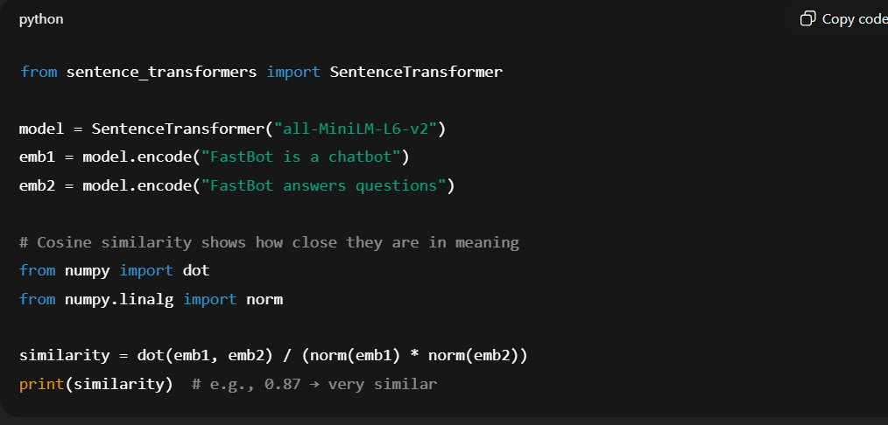

2️⃣ Deepset RoBERTa QA Model (deepset/roberta-base-squad2)

What it is:
- A pre-trained extractive question-answering (QA) model based on RoBERTa, fine-tuned on the SQuAD2 dataset.
- Extractive QA means it finds a span of text in a passage that answers the question.

Key Idea:
- Input: (context text, question)
- Output: (answer string) that exists in the context.

Why we use it in FastBot:
- After Chroma retrieves relevant document chunks, the QA model scans them to find the precise answer.
- Works with your RAG pipeline: retrieve → read → answer.

Example:
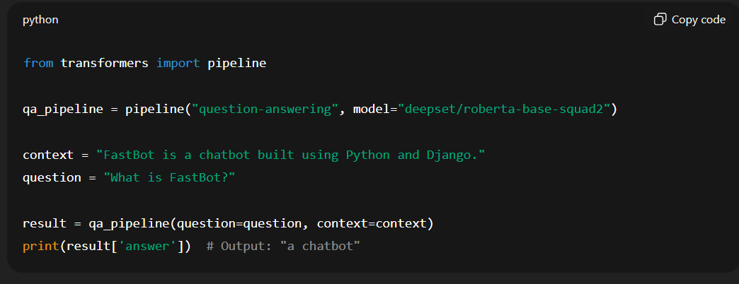

💡 How They Work Together in FastBot
- SentenceTransformer → converts all PDF/HTML text chunks into vectors → stored in Chroma.
- User asks a question → Chroma finds top-k similar chunks based on vector similarity.
- Deepset RoBERTa QA → reads those chunks → extracts the exact answer span.

🧠 What is BERT?
BERT stands for Bidirectional Encoder Representations from Transformers.
It was introduced by Google in 2018, and it completely changed how NLP models understand language.

1️⃣ What BERT Does
BERT is a language representation model — meaning it learns to understand the meaning of text by reading a large amount of data (like Wikipedia, books, etc.).
It doesn’t just look at words one by one — it looks at the full context around each word, both left and right.
That’s what the “Bidirectional” part means.
For example:
Sentence | Word | Context
“The bank will not approve the loan.” | bank | related to finance
“The fish swam to the bank of the river.” | bank | related to river
BERT can tell that “bank” means different things based on surrounding words — something older models struggled with.
BERT is a language model by Google that understands the meaning of words in a sentence by looking at the words before and after them.
It helps computers understand natural language more accurately, not just read it word by word.

🧠 Hugging Face
- A big AI platform with thousands of pretrained models for NLP (like BERT, GPT, summarizers, translators, etc.).
- You use it to load or run models (like "deepset/roberta-base-squad2" or "sentence-transformers/all-MiniLM-L6-v2").
- So — you can run models without Hugging Face, but Hugging Face is like a shortcut and toolbox that saves you all the hard setup.
➡️ Think of it as a library of smart AI models.
Why we use it:
Instead of training models from scratch, we load ready-made ones like:
"sentence-transformers/all-MiniLM-L6-v2" → to convert text into embeddings "deepset/roberta-base-squad2" → to answer questions from text
So Hugging Face = model hub + tools to run NLP models.

⚙️ LangChain
- A framework that helps connect large language models (LLMs) to data sources (like PDFs, websites, or databases).
- It handles things like splitting text, embedding, storing in vector databases, and retrieving relevant chunks for answering questions.
➡️ Think of it as a toolkit to build chatbots and RAG systems easily using LLMs.

- Why we use it:
It simplifies tasks like:
  - Loading and splitting text (e.g., from PDFs)
  - Creating embeddings
  - Saving them in a vector database (like Chroma)
  - Retrieving the most relevant chunks to answer a question
So LangChain = the bridge that connects models (from Hugging Face) with your own data — turning static text into an interactive chatbot or Q&A system.

